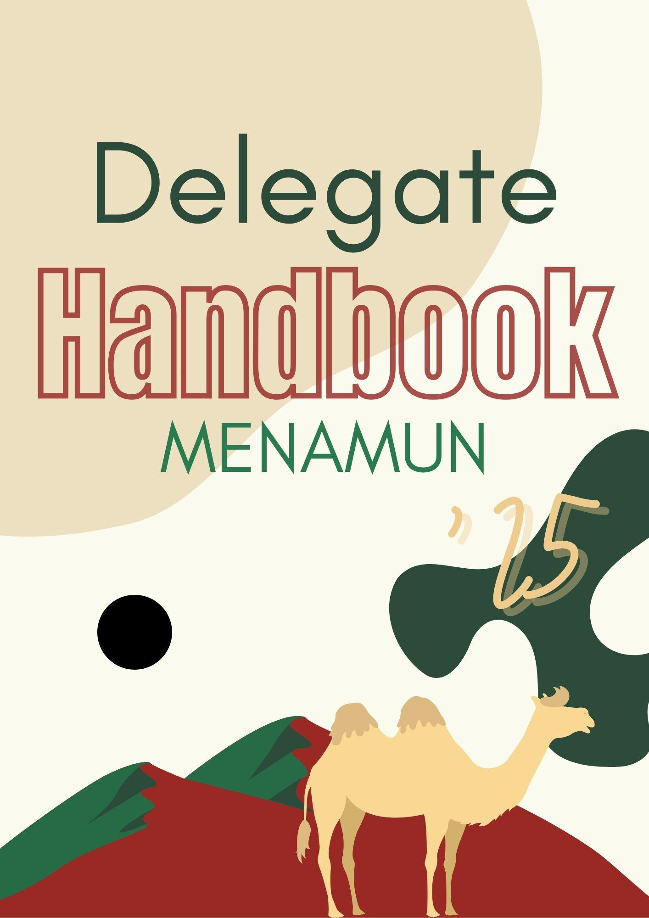
Inspired by the HUMUN handbook

The United Nations: An Overview 2
History of the United Nations 2
Structure of the United Nations 2
Core Functions of the UN 3
Achievements and Challenges 3
The Sustainable Development Goals (SDGs) 3
How to Research Your Assigned Delegation 3
The Importance of Research 3
Helpful Sources for MENA MUN 5
I. International Organizations 5
II. Regional Organizations 6
III. Privately Owned Media with a Focus on International Developments 6
IV. National News Networks 6
Flow of the Debate 7
Roll Call 7
Opening Speech 8
Lobbying and Merging 9
Event, Developpement, Crises (EDCs) 9
Tour de Table 10
Resolution Debate 10
Amendments Debate 11
Voting Procedure 11
Points 12
Interruptive Points 12
Non-Interruptive Points 12
Motions 13
Draft Resolution 14
Draft Resolution Header Format 15
Preambulatory Clauses 15
Formatting Rules 15
Types of Preambulatory Clauses 16
Common Preambulatory Clause Beginnings 16
Operative Clauses 17
Formatting Rules 17
Common Operative Clauses 18

The United Nations: An Overview

History of the United Nations
The United Nations (UN) was established on 24 October 1945, following the devastation of World War II, to prevent future conflicts and foster international cooperation. It replaced the League of Nations, which had failed to stop global war. Starting with 51 member states, the UN has grown to 193 members today, representing almost every sovereign state. Over the decades, the UN has led peacekeeping missions, advanced decolonization, promoted human rights, and coordinated global responses to humanitarian crises.

Structure of the United Nations
The UN is built around six principal organs:
- General Assembly (GA): All 193 members, debating global issues and adopting recommendations.
- Security Council (UNSC): 15 members (5 permanent with veto power); responsible for peace and security.
- Economic and Social Council (ECOSOC): Oversees economic, social, and environmental work; coordinates agencies.
- International Court of Justice (ICJ): Judicial organ that settles disputes between states and issues advisory opinions.
- Secretariat: Led by the Secretary-General; manages daily operations and implements UN decisions.
- Trusteeship Council: Established to supervise trust territories; inactive since 1994.

Core Functions of the UN
- Peace and Security: Deploys peacekeepers, mediates conflicts, imposes sanctions when needed.
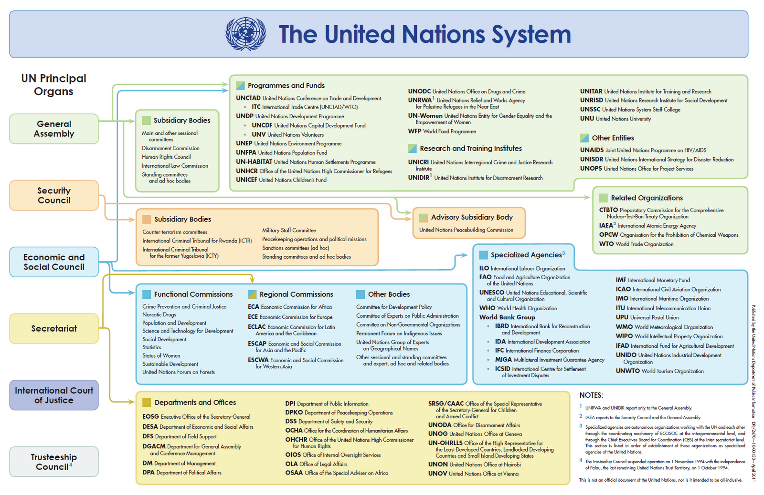
- Human Rights: Promotes and protects rights through declarations, treaties, and the Human Rights Council.
- Humanitarian Aid: Responds to disasters, conflict, and displacement via agencies like UNHCR, UNICEF, and WFP.
- Development: Promotes global progress through the 17 Sustainable Development Goals (SDGs).
- International Law: Shapes treaties and conventions; strengthens rules governing states’ behavior.

Achievements and Challenges
The UN has made notable contributions: ending colonial rule in many regions, promoting health and education, protecting refugees, and preventing conflicts from escalating. However, it also faces criticism for slow decision-making, dependency on major powers, and limits to enforcement when consensus is lacking. Balancing inclusivity with effectiveness remains a central challenge.

The Sustainable Development Goals (SDGs)
Adopted in 2015, the 17 SDGs form the UN’s global plan to end poverty, protect the planet, and ensure peace and prosperity by 2030. They cover three main areas:
- Social: health, education, equality, and reducing poverty.
- Environmental: climate action, clean energy, sustainable cities, and protecting ecosystems.
- Economic: jobs, innovation, responsible consumption, and partnerships.
The SDGs are interlinked, showing that progress in one goal supports progress in others. They remain a universal call for action to create a fairer, greener, and more peaceful world.

MENAMUN’s Committees:
The following Committees are dedicated for School level delegates only:

I- Beginner Level (Committees & Topics)

United Nations Human Rights Council (UNHRC):
- Combating Minority Discrimination in the MENA Region to Foster Stability

World Trade Organization (WTO)
- Protecting Free Trade Amid Rising Global Protectionism



II- Intermediate Level (Committees & Topics)
International Telecommunications Union (ITU)
- Strengthening global resilience of submarine cable networks

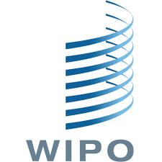

World Intellecual Property Orgnaization (WIPO) (Also UNI)
- Balancing Copyright Protection and Access to Knowledge in the Digital Age


III-Advanced Level (Committees & Topics)
International Criminal Court (ICC)
- ICC prosecutor vs Omar el Bashir



Alternate Historical Crisis Committee (Also UNI)
- Alternate Historical Crisis Committee: Pacific-European Tensions, 2020


The following committees are for university level delegates only;

United Nations Security Council (UNSC)
- Stabilizing Southeast Asia Through Peaceful Resolution of the Thailand–Cambodia Dispute

Dress Code

Think of this less like “what should I wear?” and more like “who do I want to be?” Sure, western formal works just fine, but we’re highly encouraging you to go all-in on the roleplay. Costumes, props, dramatic flair… the bigger the commitment, the more magical (and hilarious) the experience will be for everyone. Don’t be shy, this is your chance to bring your country to life!

The Archetypes of MUN delegates (with a MENA twist):

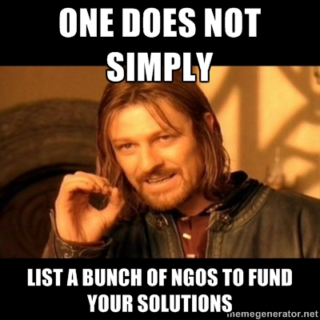
1. The Clause-King/Queen:
Every committee has that one delegate that you are certain has a PHD in creative writing . They are the delegate that probably has a clause list pinned on their wall, a thesaurus on their desk, and several UN resolutions bookmarked in their browser at all times. They craft each clause with dramatic flair, “Recalling…,” “Emphasizing…,” “Mindful of…” as if every word will be remembered for centuries. Their resolutions are impressively detailed, stuffed with references to NGOs, treaties, and obscure committees, While some delegates quietly groan, others can’t help but admire the sheer ambition, creativity, and dedication behind every perfectly punctuated and phrased clause.


2. The Sponsership Sneak
This delegate is the quiet strategist of the committee, the one behind all the great ideas yet never appears on the sponsors list.They’re humble and thoughtful, more focused on improving the resolution than seeking credit. By the time anyone notices, the draft is polished, persuasive, and deeply informed, leaving fellow delegates wondering, “Who quietly made all this happen?” PS: it was them

3. The Gavel Hunter Extraordinaire
This delegate will do everything in their willpower to catch the chair's attention; cringy jokes, clear quotes, even a dramatic cough the sky is their limit. For them the gavel is a tool , its a chance to lead, to energize the room and to ultimately win that best delegate award. They are bold, charismatic and light up every room they enter (as much as we hate its reality).

4. The Crisis Drama Kid

Crisis’s are this delegates broadway stage . While others may treat it as a serious debate, they see it as their opportunity to release their inner Lin-Manuel Miranda. Each session is a chance for full on plot twists, secret deals and dramatic speeches.One moment they’re plotting espionage, the next they’re making bold ultimatums, always keeping the room on edge. For them MUN isnt just a conference it is a performance.


5. The Research Librarian
Quiet, thoughtful, and always prepared, this person isn’t the loudest voice in the room, but when they do speak, everyone listens. They may not try to dominate debates or win arguments with sheer force of personality, but instead rely on something far more convincing: facts. Whether it’s pulling data from the CIA World Factbook, citing obscure UN voting records, or referencing a little-known international report, they always seem to have exactly the right source at hand. Their style isn’t flashy, but it’s steady, reliable, and impossible to ignore once they’ve laid out the evidence.

How to Research Your Assigned Delegation

The Importance of Research
In MUN, your research defines the quality of your performance. To speak confidently and negotiate effectively, you must think like your delegation. Whether you represent a country or an organization, your goal is to defend their interests as if you were a real diplomat.

Step 1: Build a Foundation
Start with the essentials: get to know your delegation in a broad sense.
- For a country: geography, population, economy, government system, and major cultural features.
- For an organization: founding date, mandate, membership, funding, and key objectives.
This basic knowledge will allow you to speak with authority when introducing your delegation.
Step 2: Learn Its Global Identity
Every delegation has a place in the world:
- Alliances and partnerships: What regional blocs or alliances does it belong to (e.g., EU, AU, ASEAN, OPEC)?
- Relations with others: Who are its closest allies? Who are its rivals?
- International reputation: How is it usually perceived in the UN? A major power, a mediator, a developing country, or a specialized body?
This step helps you predict who might support or oppose your proposals.

Step 3: Connect to the Agenda
General knowledge is not enough — tie it to the committee’s topics.
- Read official UN reports and resolutions on the agenda.
- Search for your delegation’s past statements or voting records.
- Identify how the issue directly affects your delegation (e.g., climate change for island states, trade sanctions for exporters, health crises for WHO).
Ask yourself: Why does this topic matter to my delegation?

Step 4: Identify Interests and Red Lines
Now, move from knowledge to diplomacy:
- Priorities: What does your delegation want to achieve in this debate?
- Compromises: What could it accept if negotiations require flexibility?
- Red lines: What positions can it never support?
Understanding these three levels ensures you negotiate like a real representative, not like yourself.

Step 5: Deepen with Official Sources
To avoid guesswork, rely on primary sources:
- Countries: Ministry of Foreign Affairs, embassies, official speeches at the UN.
- Organizations: Mandates, charters, annual reports, and official press releases.
- General references: UN Digital Library, CIA World Factbook, BBC Country Profiles, World Bank, and IMF data.
Official sources help you sound credible and precise.

Step 6: Organize Your Research
A well-prepared delegate is also well-organized. Summarize your findings into a delegation profile with these sections:
- Basic facts (location, system, population, economy).
- Alliances and memberships (regional and global).
- Stance on committee topics (supported by past actions or statements).
- Quotes/data you can use in speeches.
- Strategy: your goals, allies, and likely compromises.
This one-page document becomes your “cheat sheet” during debate.

Step 7: Practice Thinking Like Your Delegation
Finally, put yourself in their shoes.
- If you represent a country: Imagine you are its ambassador. Every sentence should align with its culture, interests, and policies.
- If you represent an organization: Speak from its mandate. Ask, What would my organization recommend in this debate?
The goal is to speak so persuasively that others in the room believe you are that delegation.
Add a research flowchart: “Start → Foundation → Global Identity → Agenda → Interests → Sources → Strategy.”

Helpful Sources for MENA MUN

I. International Organizations
- United Nations (UN) and UN Agencies: UN, WHO, UNICEF, UNESCO, FAO, WMO, IMO, ILO, UNHCR, UNODC, OPCW, ICJ, ICC
- Other International Organizations: Interpol, IMF, World Bank Group, ICRC, Transparency International, Human Rights Watch, Lemkin Institute for Genocide Prevention

II. Regional Organizations
- Europe & Eurasia: EU, NATO, EAEU, CSTO
- Americas: Organization of American States (OAS)
- Africa & Middle East: African Union (AU), Arab League
- Asia & Pacific: SCO, ASEAN
- West Africa: ECOWAS

III. Privately Owned Media with a Focus on International Developments
- Reuters, AP, AFP, Bloomberg, Euronews, CNN, South China Morning Post, Al Monitor

IV. National News Networks
United States
- CIA, FBI, White House, C-SPAN, Federal Register
- MSNBC, PBS, Fox News, The New York Times, Washington Post
Russia
- RT, Sputnik, TASS
People’s Republic of China
- CCTV, CGTN, Global Times
France
- France 24, Le Monde, Radio France International
United Kingdom
- BBC, The Guardian, The Independent, Gov.uk
Germany
- DW, Der Spiegel, Deutschland.de
Spain
- El País, La Moncloa
Lebanon
- MTV, Al Jadeed, LBC, Al Manar, National News Agency, Al Mayadeen
Armenia
- Armenpress, Public Radio of Armenia, Civilnet, Hetq
Turkey & Azerbaijan
- Agos, TRT, Daily Sabah, Hürriyet, Trend.az, Caliber.az
Syria & Iran
- SANA, Press TV, IRNA, Mehr News Agency
Saudi Arabia & Qatar
- Al Arabiya, Al Hadath, Arab News, Al Jazeera, AJ+, Doha News
India
- The Times of India, The Print, WION, The Indian Express
South Korea
- The Korea Herald, The Korea Times, Yonhap News Agency
Japan
- Yomiuri Japan News, The Japan Times, Japan Today

Flow of the Debate

Roll Call
In Model United Nations, roll call serves as the formal way of taking attendance at the beginning of each committee session. During roll call, delegates must state their status as either “present” or “present and voting.”
- Saying “present” means the delegate is attending the session but retains the right to abstain when it comes to voting on draft resolutions or amendments. This option is usually chosen by countries that wish to remain neutral or flexible on the issue being debated.
- Saying “present and voting” commits the delegate to casting a definitive yes or no vote on all substantive matters. Delegates cannot abstain if they select this option, which is why it is generally chosen by countries with strong, clear positions on the topic.
It’s important to note that delegates who initially say “present” may later switch to “present and voting” in subsequent roll calls if they wish. However, once a delegate has declared themselves “present and voting,” they may not revert back to simply “present.”
In short, roll call not only confirms attendance but also indicates the level of commitment and engagement each country intends to take in the decision-making process.
#we may add a similar diagram
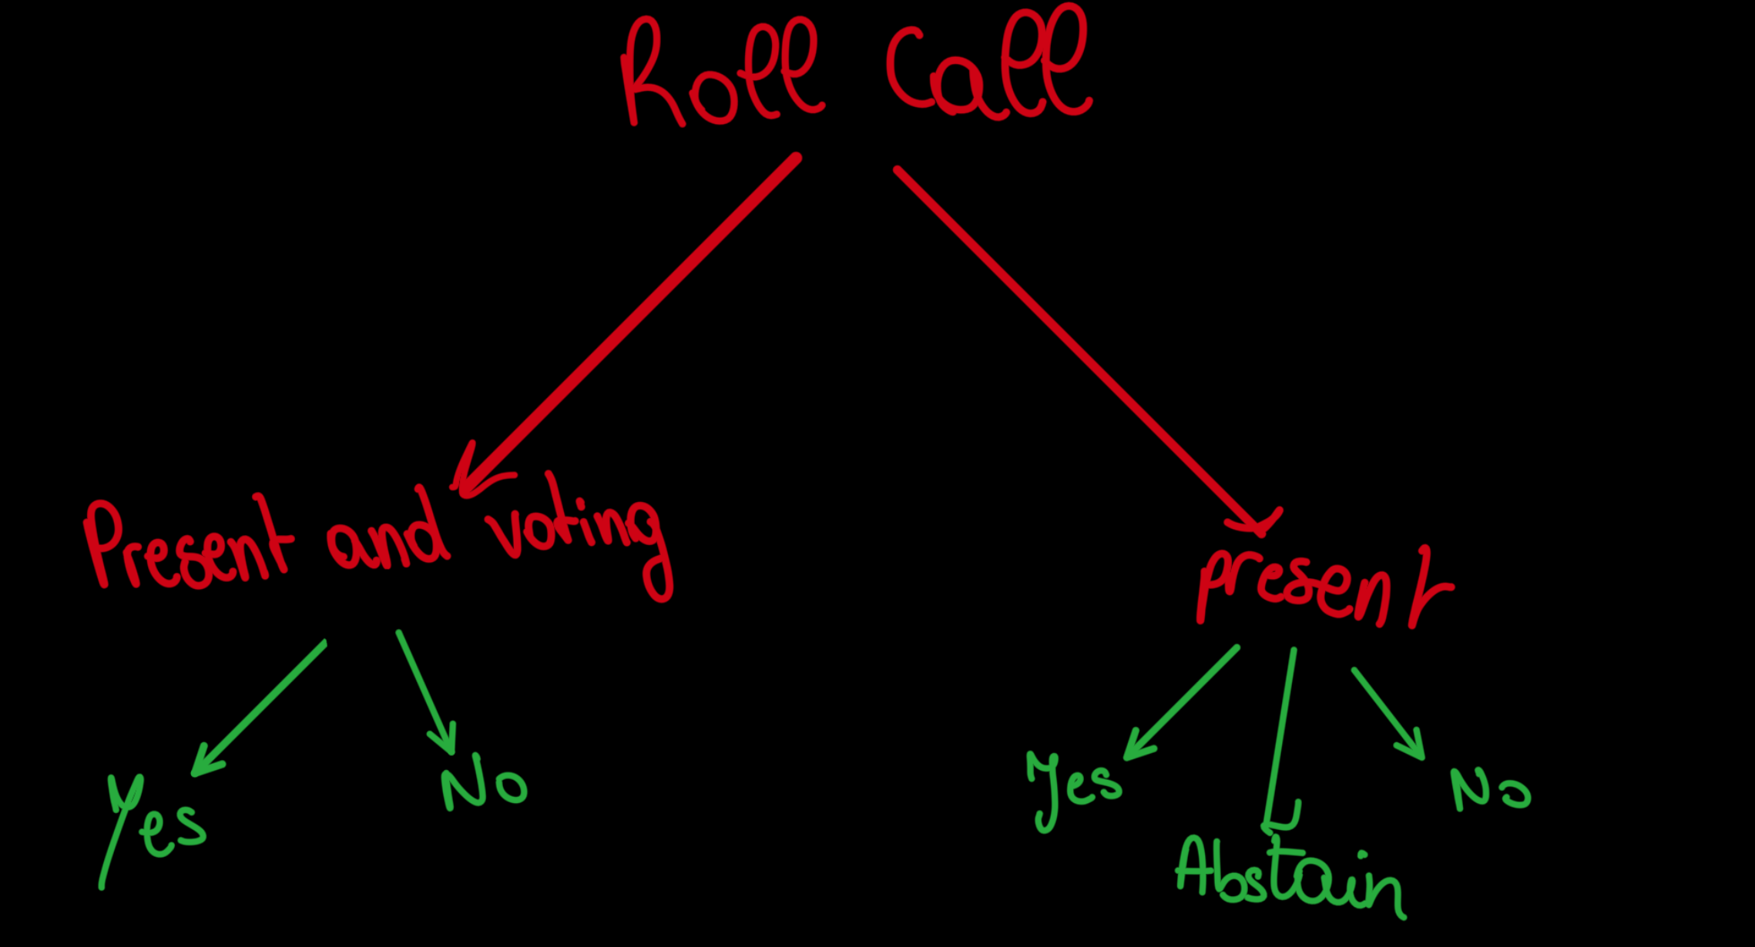

Opening Speech
In every Model United Nations committee, delegates are required to deliver an opening speech at the start of debate. This is each country’s chance to formally introduce itself, highlight its key priorities, and outline the direction it intends to take on the issue being discussed.
The speeches are intentionally kept short—usually about one minute per delegate in most committees, and slightly longer (around two minutes) in the Security Council. Because every delegate must participate, this segment of debate can take quite some time, often stretching to a couple of hours depending on the size of the committee.
What makes opening speeches especially valuable is not only the chance to present your own country’s stance, but also the opportunity to listen closely to others. The positions revealed during this stage help delegates identify potential allies, recognize opposing interests, and prepare for the lobbying and merging phase that follows.
Once a speech is delivered, delegates may have a few options (if they had remaining time) for how to yield the floor:
- Open to questions: This allows fellow delegates to directly engage with the speaker, asking for clarification or pressing on weaknesses in their argument. Such exchanges may turn into short but lively confrontations that sharpen the debate.
- Pass the floor to another delegate: This can be used strategically, either to strengthen coordination with an ally or to challenge a rival by putting them on the spot. The chosen delegate must, however, agree to accept the floor.
- Yield back to the chair: The most neutral option, ending the intervention without further interaction.
In short, opening speeches set the tone for the entire committee. They showcase each country’s priorities and open the door to cooperation, negotiation, and sometimes early confrontation.

Lobbying and Merging
Lobbying and Merging takes place right after opening speeches. At this stage, a delegate must motion for lobbying and merging, stating its purpose and allocated time. Once approved, the committee moves into an unmoderated caucus where delegates can freely move, form blocs, and start working together.
Before writing a draft resolution, delegates usually begin with a working paper. A working paper is an informal document that lists ideas, possible solutions, and bullet points. It helps blocs organize their thoughts before turning them into a structured draft resolution.
During this phase, delegates are expected to base their stance on their country’s policies, not their personal opinions. They exchange positions, negotiate, and compromise until they can merge their ideas into a single resolution that reflects the interests of most of their bloc.
Once a draft resolution is ready, the Main Submitter passes it to the Approval Panel (the Chairs). The panel reviews it for clarity, format, and originality. If plagiarism is detected, the resolution will be disqualified, and the delegate responsible will face consequences.
Throughout, Chairs closely monitor the process (both to ensure proper conduct and to observe how blocs and alliances form.)

Event, Development, Crises (EDCs)
In MENA MUN, debates are never meant to stay still. The real world is constantly shifting, and so must our simulation. This is why we introduce EDCs (Events, Developments, and Crises.)
- An Event might shake the room in an instant — a sudden announcement, a breaking news headline, or an unexpected decision by a state.
- Development is slower but steady — the change of alliances, new economic moves, or internal tensions building up.
- A Crisis is when things boil over — wars, revolutions, disasters, or any turning point that forces delegates to act quickly.
EDCs keep committees dynamic. They ensure that no policy, no alliance, and no assumption is ever permanent. What looks minor at first may later dominate the debate. Delegates must stay alert, flexible, and ready to adjust their strategies.
After an EDC is introduced, the delegate directly targeted by it must state their country’s stance and how they intend to respond. Following that, other delegates may also express their positions, showing how their states would react to the new situation.
Example of an EDC in the WHO Committee
The committee is debating global health cooperation when an EDC is announced:
“Breaking News: A cholera outbreak has been reported in several regions of Lebanon, affecting thousands of civilians and overwhelming hospitals.”
- Lebanon, as the directly targeted country, must state its stance first — for example, requesting international aid, stressing the need for medical supplies, or highlighting national efforts to control the outbreak.
- After Lebanon’s response, other delegates (such as neighboring states or donor countries) can also state their positions, offering support, proposing aid packages, or raising concerns.
This pushes the debate into a new direction: How should the WHO and the international community respond to this sudden health emergency?

Tour de Table
A Tour de Table is a formal, concise statement delivered by each delegate—typically at the opening of the second day of committee sessions. Its purpose is to provide a comprehensive briefing on developments from the previous day, clarify national positions, and guide the committee’s deliberations moving forward.
During the Tour de Table, delegates are expected to:
- Summarize Progress: Outline key initiatives, negotiations, or proposals undertaken in the previous session.
- Refine Positions: Reaffirm or adjust their stance in light of emerging developments or consensus-building efforts.
- Call for Constructive Action: Encourage collaborative engagement and foster momentum for committee resolutions.
Protocol and Guidelines:
- Speaking Order: Determined by the dais or chair.
- Time Limit: Strictly 30–40 seconds per delegate.
- Mandatory Participation: All delegates must address the committee.

Resolution Debate
Resolution Debate is when delegates present and defend their bloc’s proposed solution to the committee. The main submitter presents the draft resolution, while co-submitters are expected to answer any questions from the committee.
Supporters then speak to persuade delegates to adopt the resolution, while opponents respond with arguments against it, pointing out flaws or conflicts with state interests. If multiple blocs have similar resolutions, merging is encouraged; if not, delegates focus on defending their own resolution while challenging others.
This stage mirrors real-world diplomacy: compromise is ideal, but if agreement isn’t possible, it’s better to block a weak resolution than pass one that fails to address the topic effectively.
Debates over resolutions and amendments are usually among the most dynamic parts of the conference. Speeches can last several minutes, and combined with amendment discussions, this portion can take several hours, making it one of the most strategic and engaging phases of the session.

Amendments Debate
Amendments are proposed changes to the resolution currently under discussion and can be presented by any delegate in the committee, not just the submitters. They can be friendly or unfriendly.
- A friendly amendment is one that the main submitter agrees with, usually adding, removing, or clarifying clauses without changing the resolution’s overall intent.
- An unfriendly amendment is one that the main submitter does not agree with, often altering or removing clauses in a way that could weaken or redirect the resolution. Unfriendly amendments trigger a debate, where delegates discuss and negotiate to find a compromise acceptable to both the submitter and the committee.

All amendments must be written and submitted to the Chair, via the committee Admin, before being considered for debate.
Amendment debates follow a similar procedure to resolution debates but are shorter. At the end of discussion, delegates vote on the amendment, with no option to abstain. If ⅔ (66%) of the original resolution’s clauses are removed through amendments, the resolution automatically fails.

Voting Procedure
During voting, delegates decide on resolutions and amendments. Delegates who are present and voting must vote either in favor or against. Delegates who are present may choose to abstain, unless a motion to divide the House is called, which requires everyone to vote.
For a resolution to pass, it must receive a majority of votes — that is, 50% plus one of the votes cast.
In the Security Council, only member states can vote. Observers do not have voting rights and are considered to abstain automatically. Additionally, the five permanent members (P5) hold veto power: if any of them veto a resolution, it automatically fails, regardless of the majority. All vetoes must be well-justified; otherwise, they may be disregarded.

Points

Interruptive Points
These points allow a delegate to interrupt the flow of debate for urgent or immediate matters.
- Point of Personal Privilege
A verbal point used for personal issues unrelated to the debate. Examples include: requesting a break, reporting that you cannot hear the speaker, or adjusting room temperature. Delegates should use this sparingly, as excessive use may lead the chair to stop recognizing it.
- Point of Order
A verbal point used when the chair makes a procedural mistake or overlooks a rule. For instance, if a delegate’s speech exceeds the allotted time and the chair does not intervene, another delegate may raise this point. It should only be used when truly necessary, not to challenge the chair unnecessarily.

Non-Interruptive Points
These points are addressed without disrupting the current speaker and allow delegates to seek clarification or guidance.
- Point of Information
This point is used when a delegate wants to ask another delegate a question or request clarification about their speech. After a delegate finishes speaking, the chair may open the floor for POIs and select delegates to ask their questions.
- Request for Follow-Up
This point is used after a Point of Information if a delegate wishes to ask an additional question or seek further clarification from the speaker.
- Point of Parliamentary Inquiry
Can also be verbal or written. This point is raised to ask the chair about procedural rules or the flow of debate, such as clarification on voting percentages or how a motion should be submitted.

Motions
Motion | Purpose / Definition | Voting / Approval | Example
Motion to Move into a Head-to-Head Debate | Verbal motion to debate one-on-one with a delegate, moderated by chairs. | Chair approval | Two delegates argue directly on a topic while others watch.
Motion to Solicit Third Party | Written motion to request involvement of another committee, expert, or delegate. | Chair approval | Ask UNSC to consider sanctions requested by another committee.
Motion to Divide the House | Verbal motion to force all present delegates to vote, including abstentions. | Requires seconding and >2/3 majority | Forces all delegates to vote on a resolution.
Motion to Adjourn the Debate | Verbal motion to end the session or take a break. | 50%+1 | Ends the debate for the day.
Motion to Move into Lobbying and Merging Stage | Verbal motion to allow negotiation and merging of ideas or draft resolutions; purpose and time must be stated. | 50%+1 | Blocs start writing their Working paper.
Motion to Move to Resolution Debate | Verbal motion to start formal debate on drafted resolution(s). | 50%+1 | Begin discussing and debating a draft resolution.
Motion to Move to Amendment Debate | Verbal motion to start discussion on amendments to a resolution. | 50%+1 | Debate changes proposed to an article in the draft resolution.
Motion to Move to Voting Procedure | Verbal motion to start official voting on resolutions or amendments. | 50%+1 | Begin the voting procedure for a resolution.
Right of Reply | The right of reply allows a delegate to respond when another delegate makes accusations, offensive remarks, or false statements about their country. A right of reply cannot be used in response to another right of reply; in such cases, the delegate must motion to enter a head-to-head debate. | Chair approval | The USA delegate accuses India of deliberately withholding climate data, calling it “irresponsible and dangerous for global safety.” India’s delegate requests a right of reply. If approved by the chair, India’s delegate is given a short time to firmly refute the accusations and defend their country’s actions.

Draft Resolution
Before attending the conference, it’s important to prepare some resolutions, not as a draft resolution, but as bullet points, ideas, or any relevant points you can use for lobbying. The draft resolution includes the background action to the issue (preambulatory clauses) and the country’s position through recommendations (operative clauses). These two sets of clauses should align closely with the information in your policy statement.
For a Draft Resolution to be considered by the committee, at least 20% of the quorum must sign it. A signatory can agree with the suggested solutions, have contributed to the ideas, or simply want the paper discussed, even if they don’t fully approve. This means a delegate can sign multiple Draft Resolutions and criticise them, as being a signatory just means they want the draft resolution debated.
To gain the dais members’ approval and begin referring to the document as a draft resolution, a certain format must ensue. It consists of a heading, preambulatory clauses, and operative clauses.

Draft Resolution Header Format
Draft Resolution Number:
- Written as DR/Committee/Number (e.g., DR/SPECPOL/1/2025).
Committee:
- Full name of the committee (e.g., General Assembly Third Committee (SOCHUM)).
Topic:
- The agenda item being debated.
Main Submitter(s):
- Country/countries that drafted and take ownership of the resolution.
- Maximum of two main submitters.
- Must have played an active role in drafting.
- They present and defend the text during debate.
- Cannot also be signatories.
Co-Submitters:
- Countries that helped draft and support the resolution.
- Remain officially tied to it once submitted.
Signatories:
- Countries that support bringing the resolution to debate.
- Do not necessarily agree with the content.
- Role is only to allow discussion, not ownership.

Preambulatory Clauses
Preambulatory clauses explain why the draft resolution is being written. They define the problem, refer to past UN actions or treaties, and highlight key facts or events that justify the resolution.

Formatting Rules
- Each clause begins with a Italic present participle verb (e.g., Recognizing, Reaffirming, Deeply concerned).
- Each clause is written on a separate line.
- Clauses end with a comma (,).
- The preambular section begins with:
“The [Name of the Committee],”
(e.g., “The General Assembly Third Committee,”)

Types of Preambulatory Clauses
- Reference to previous UN resolutions
Recalling General Assembly resolution 70/1, which adopted the 2030 Agenda for Sustainable Development,
- Reference to past UN actions or conventions
Recognizing the significance of the Paris Agreement as a global effort to address climate change,
- Statements by UN officials, states, or international figures
Taking note of the remarks by the Director-General of the World Health Organization on the importance of global preparedness for pandemics,
- Facts, statistics, and evidence
Alarmed by the UNHCR report indicating that the number of forcibly displaced people worldwide has surpassed 100 million,

Common Preambulatory Clause Beginnings

Category | Examples
General Acknowledgment | Affirming, Believing, Confident, Convinced, Fully believing, Fully aware, Deeply convinced
Concern / Alarm | Deeply disturbed, Alarmed by, Fully alarmed, Deeply concerned, Deeply conscious, Noting with deep concern
Regret / Deploring | Deeply regretting, Noting with regret, Further deploring
Recognition / Awareness | Aware of, Recognizing, Realizing, Keeping in mind
Reference to Past Actions | Recalling, Further recalling, Noting, Taking note, Noting with satisfaction
Consideration / Examination | Having considered, Having considered further, Having examined, Having studied, Having heard, Having received, Having devoted attention
Guidance / Emphasis | Guided by, Emphasizing, Bearing in mind, Fulfilling
Forward-Looking / Expectation | Expecting, Contemplating, Further seeking, Declaring

Operative Clauses
Operative clauses present the solutions and actions that the committee proposes. They are the heart of the resolution, turning discussion into concrete measures.

Formatting Rules
- Numbering:
- Each operative clause is numbered consecutively (1, 2, 3…).
- Punctuation:
- Clauses are separated with a semicolon ( ; ).
- The second-to-last clause ends with “; and”.
- The final clause ends with a period.
- Wording:
- Each clause begins with an underlined present-tense verb (e.g., Urges, Calls upon, Requests).
- Sub-Clauses:
- Sub-clauses expand or clarify the main clause.
- They are introduced with a colon (:).
- At least two sub-clauses are required if sub-clauses are used.
- Sub-clauses are lettered (a, b, c, …).
- Punctuation for Sub-Clauses:
- Sub-clauses are separated by commas ( , ), except for the last one, which ends with a semicolon.
- Sub-Sub-Clauses:
- If further detail is needed, sub-sub-clauses may be added.
- They follow the same structure as sub-clauses and are numbered with lowercase Roman numerals (i, ii, iii …).

Common Operative Clauses
Category | Examples
Strong / Binding Action | Authorizes, Declares accordingly, Condemns, Demands, Resolves, Further resolves
Moderate / Directive Action | Calls, Calls upon, Urges, Requests, Further requests, Proposes, Suggests, Designates
Supportive / Endorsing Action | Approves, Endorses, Supports, Affirms, Confirms, Expresses its hope
Advisory / Recommending Action | Encourages, Recommends, Further recommends, Asks, Considers, Further reminds
Highlighting / Drawing Attention | Accepts, Draws attention, Emphasizes, Further invites, Further proclaims, Transmits, Deplores

